PICO
- The Numbers
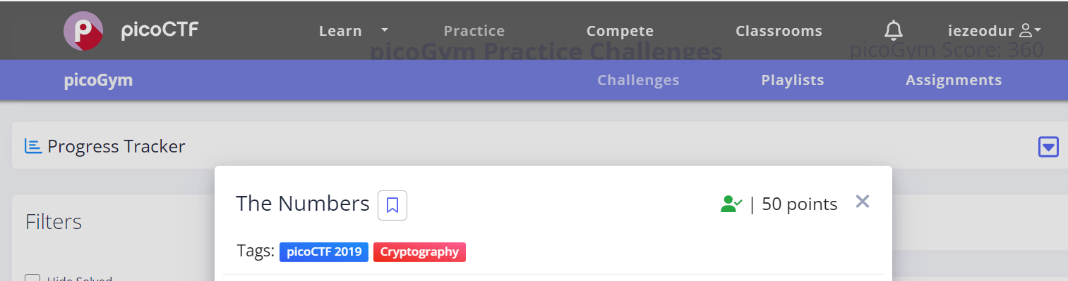
- Number was 16 9 3 15 3 20 6 {20 8 5 14 21 13 2 5 18 19 13 1 19 15 14}. Converted it to what letters they represented in the alphabet terms to get PICOCTF{THENUMBERSMASON}.
- Mod 26
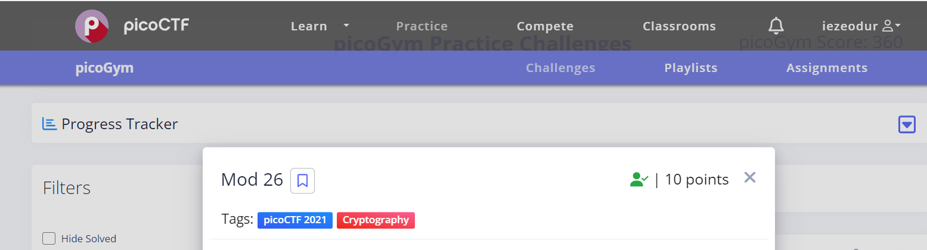
- Converted using ROT13 from https://www.cachesleuth.com/. cvpbPGS{arkg_gvzr_V'yy_gel_2_ebhaqf_bs_ebg13_MAZyqFQj} to picoCTF{next_time_I'll_try_2_rounds_of_rot13_ZNMldSDw}
- caesar
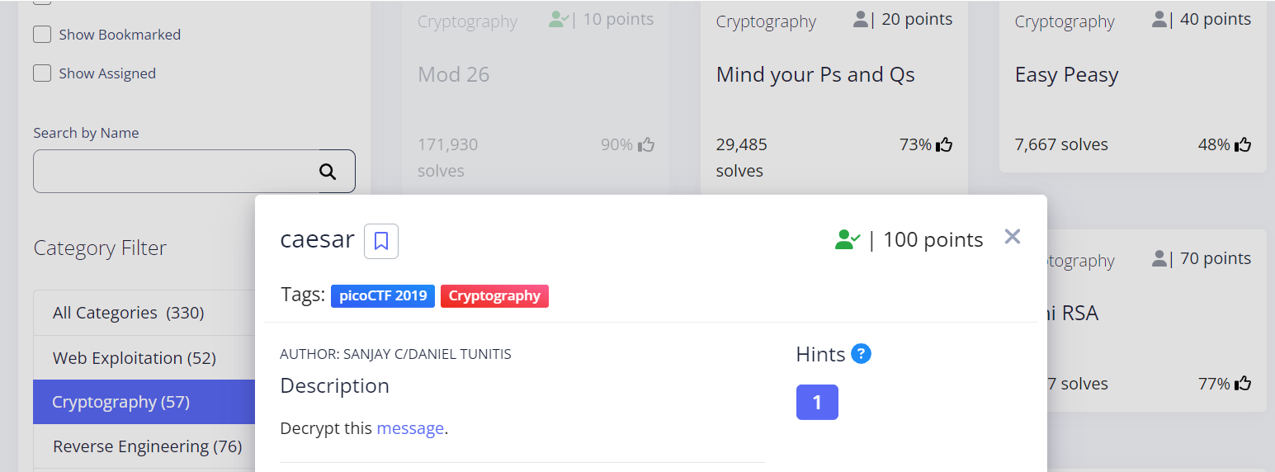
- Using ceasar on cipher https://www.dcode.fr/caesar-cipher to brute force, the highlighted flag picoCTF{dspttjohuifsvcjdpoabrkttds} which translated to “crossingtherubiconzaqjsscr”.

- morse-code
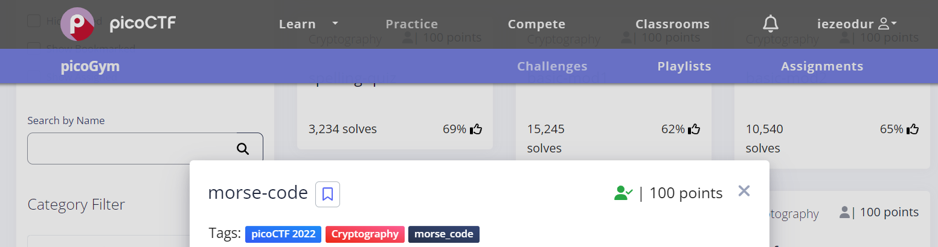
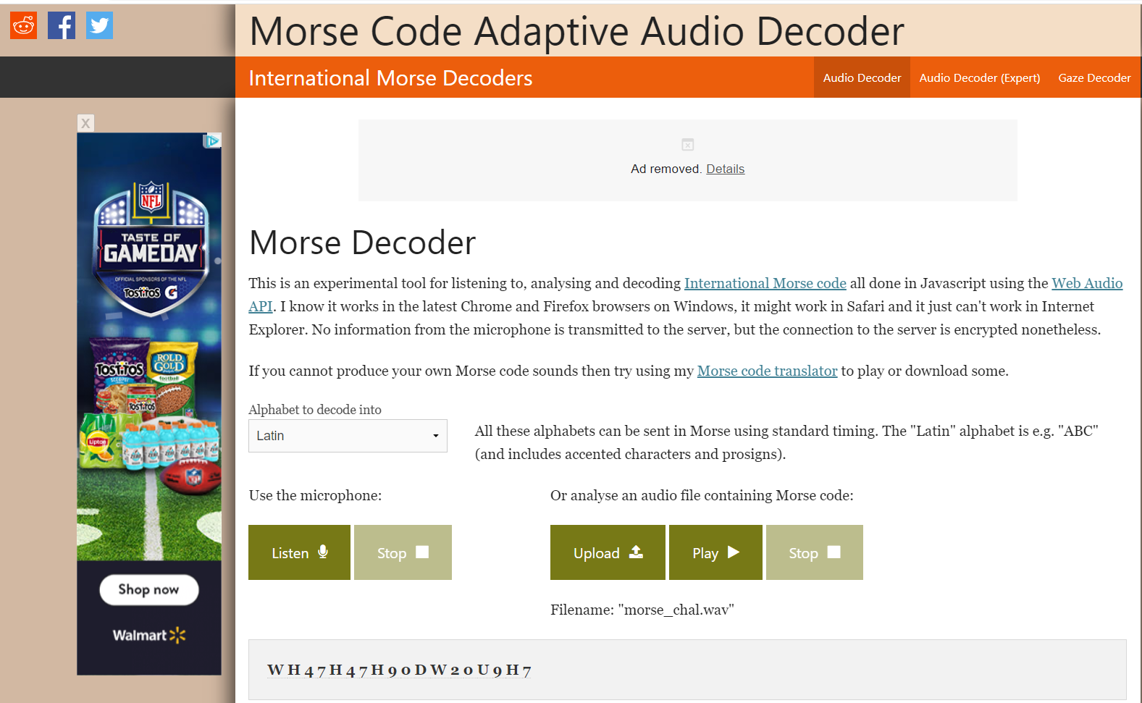
- Uploaded audio file to https://morsecode.world/international/decoder/audio-decoder-adaptive.html
- Viginere
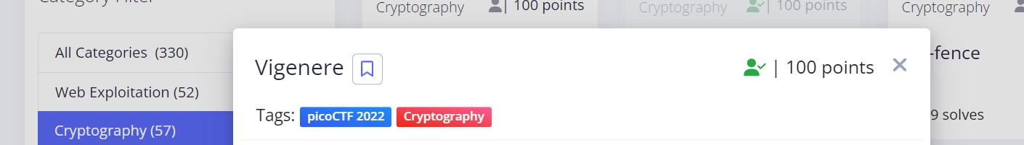
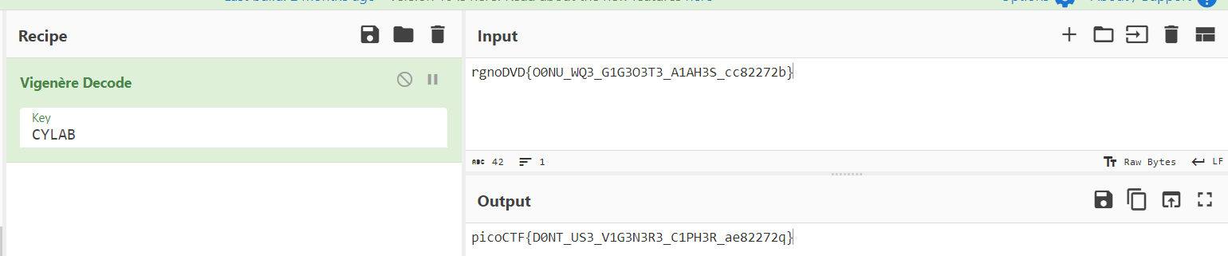
- Decode flag with given key using https://gchq.github.io/CyberChef/#recipe=Vigen%C3%A8re_Decode('')
- Insp3ct0r
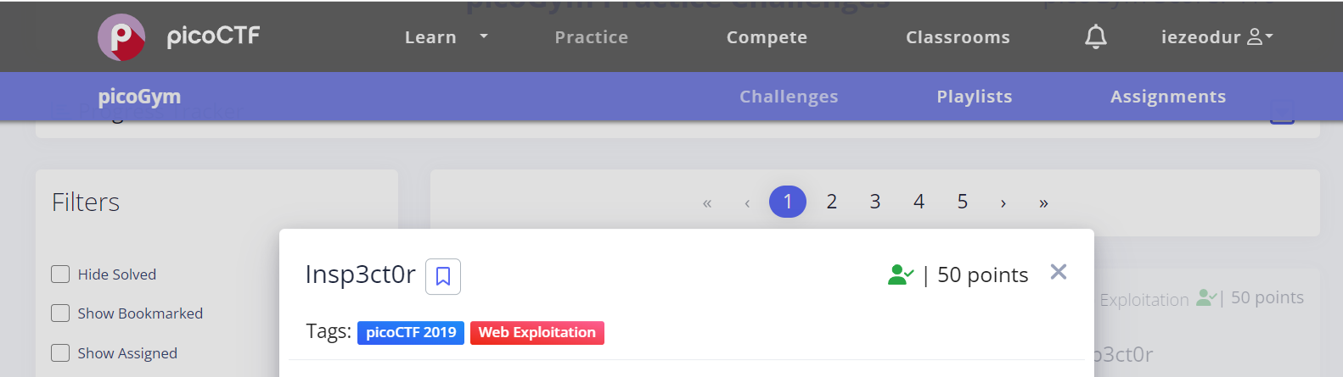
- Flags were hidden in the source page files –
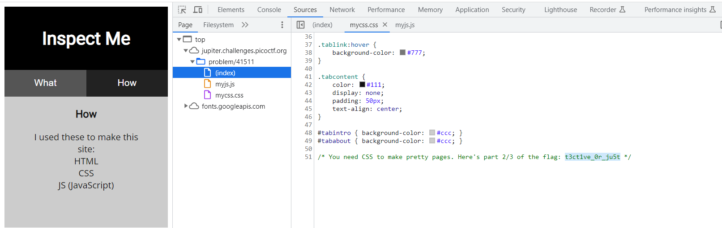

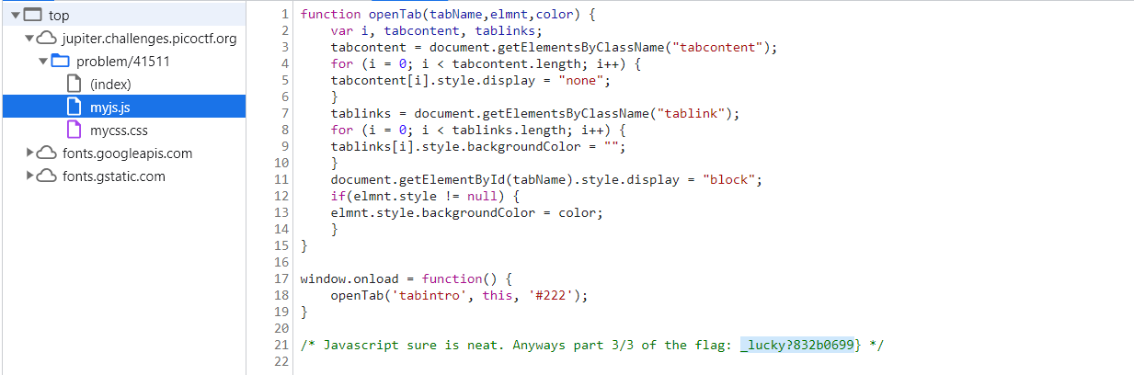
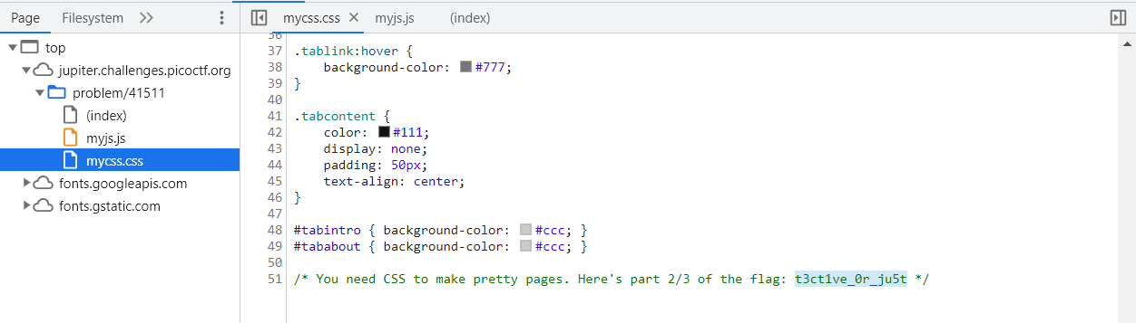
- Easy1
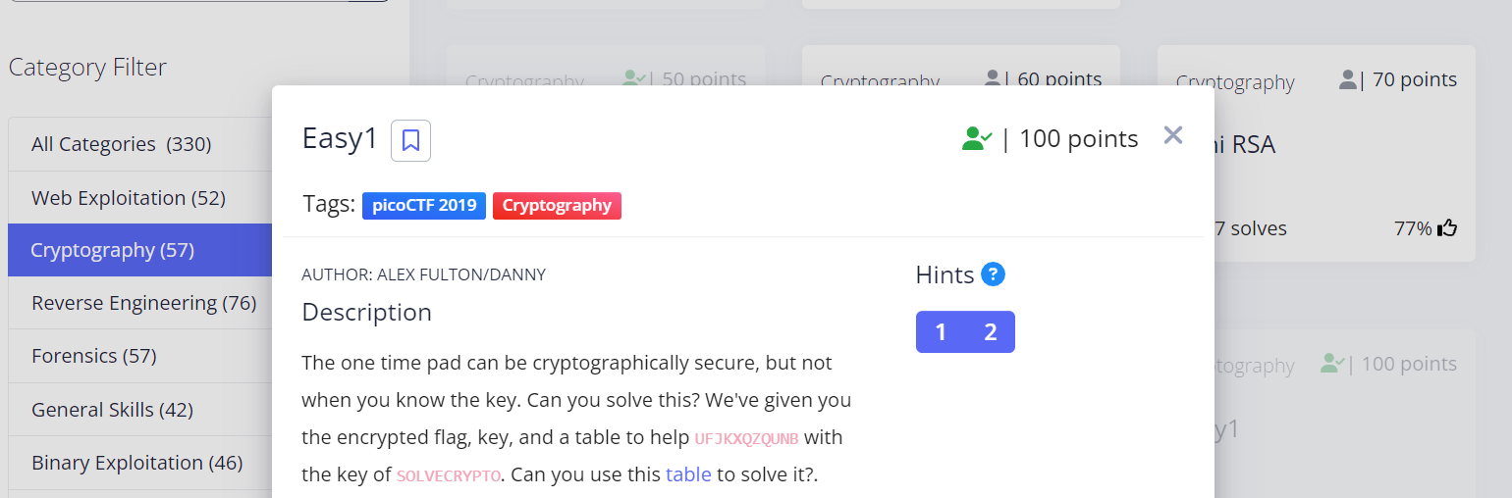
- What combine with the key SOLVECRYPTO gives UFJKXQZQUNB?
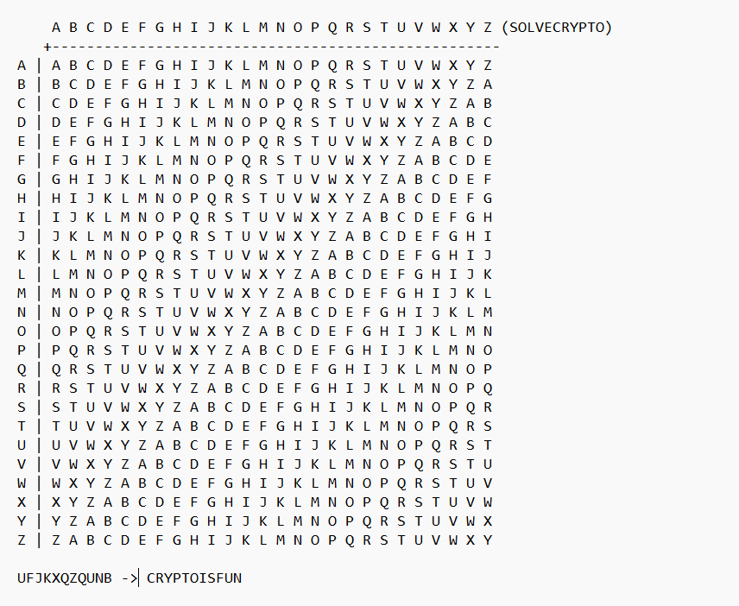
- login
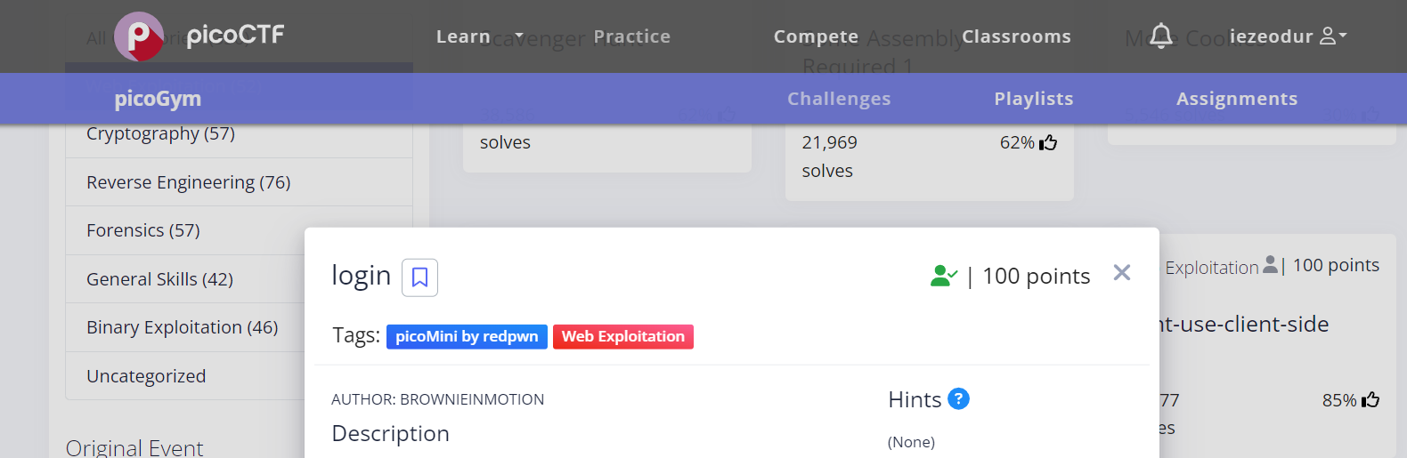
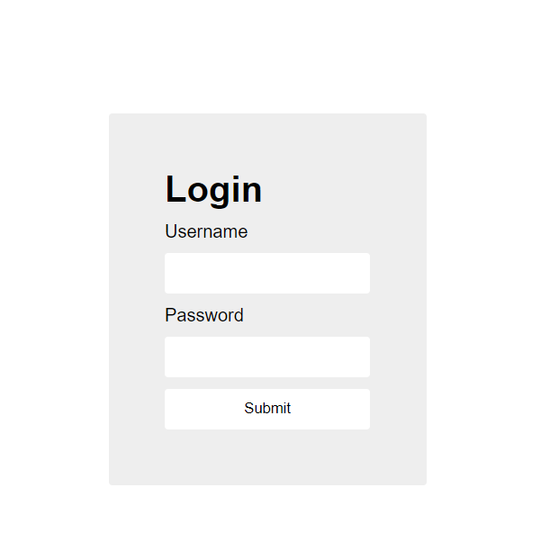
- Flags, in base64 format, was hidden in the source page file, index.js –
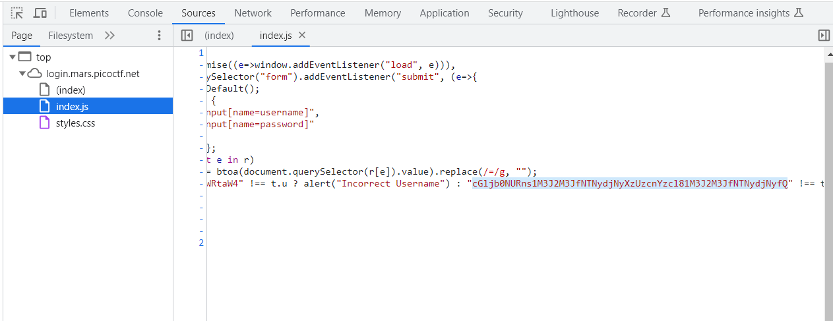
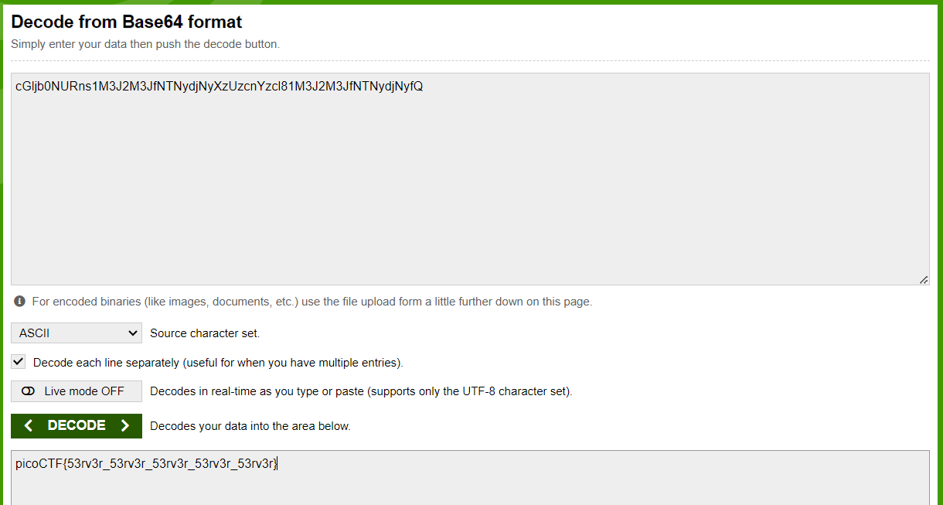
- Decoded base64 string using https://www.base64decode.org/
- It is my Birthday
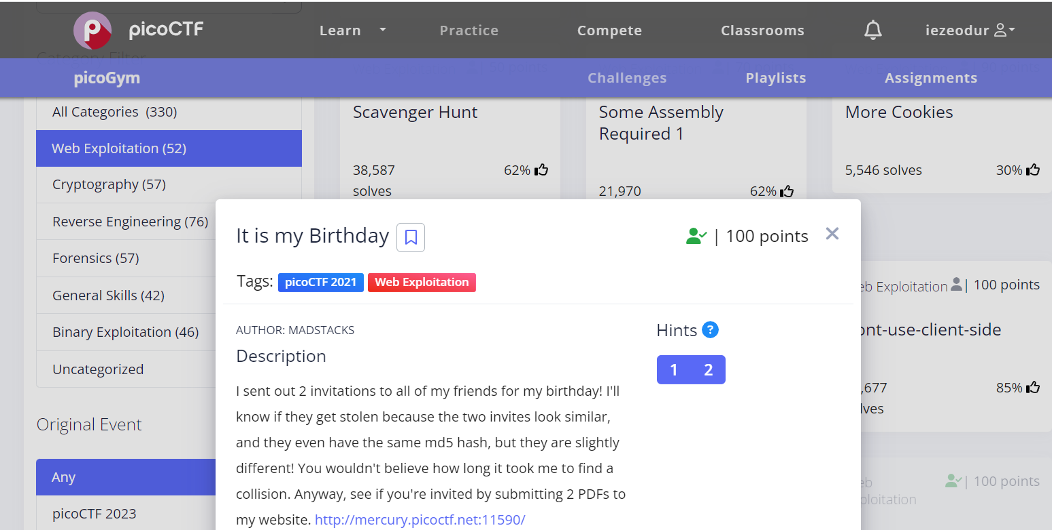
- https://www.mscs.dal.ca/~selinger/md5collision/ contains some known collision.
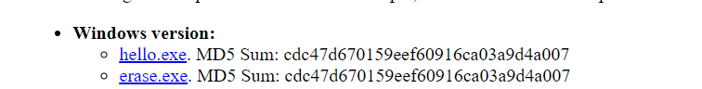
- Downloaded the windows version in .exe. Renamed file extension to pdf since it was the file type that was specified by the site.
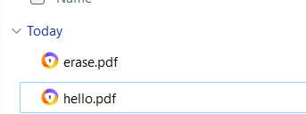
- Uploaded file to website which redirected me to a html file with the flag.

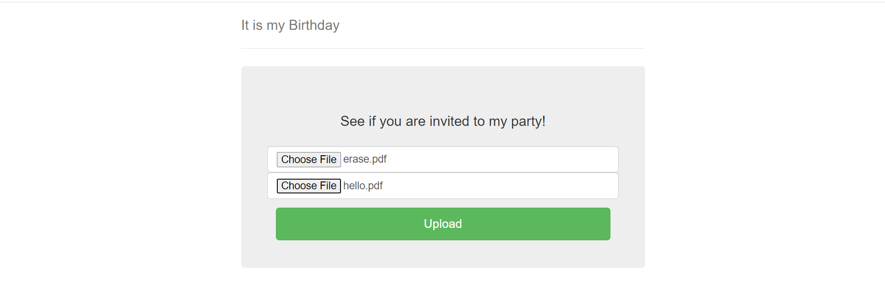
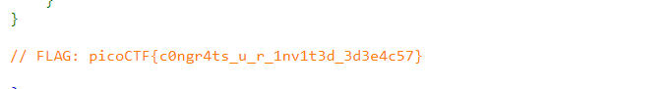
- Some Assembly required 1
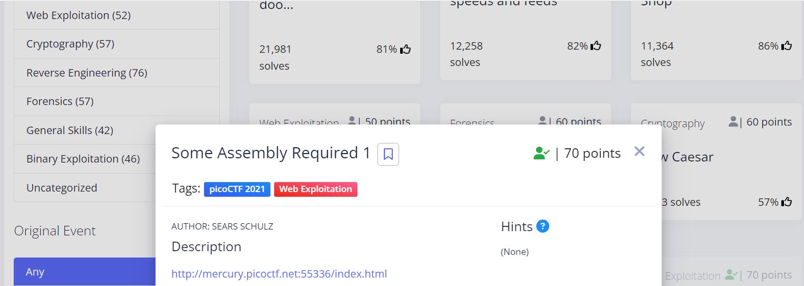
- Scanning through the html file path in source page.
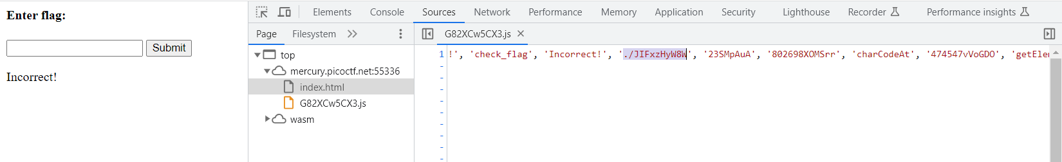
- Accessing this file path http://mercury.picoctf.net:55336/JIFxzHyW8W opened up a txt file containing the flag.
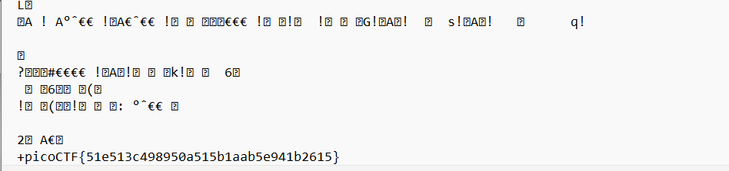

CTFLearn
- Substitution Cipher
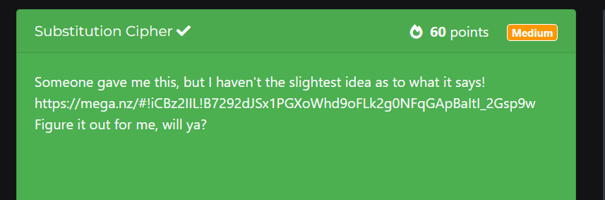
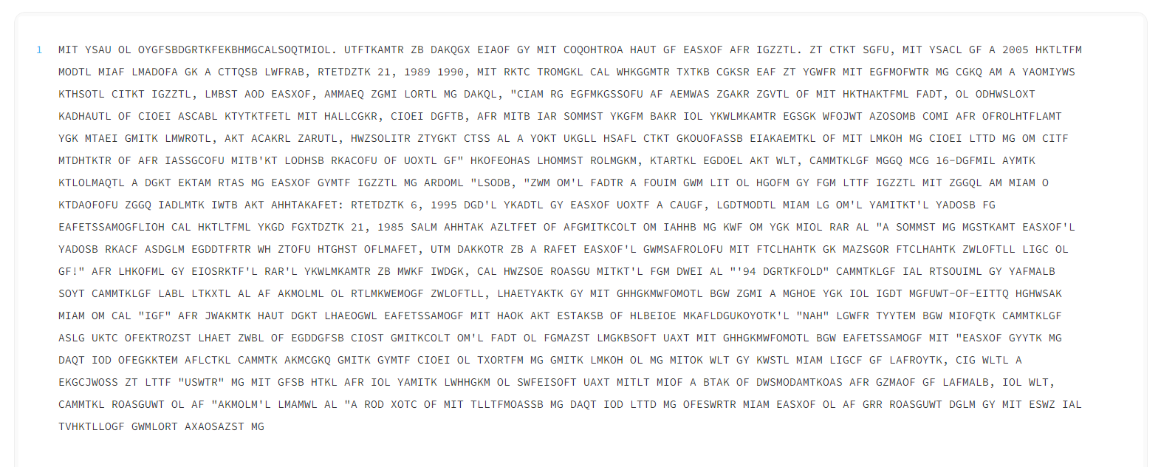
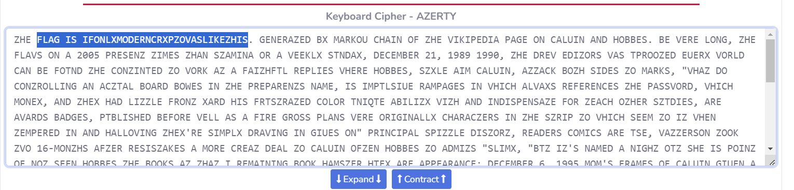
IF ONLY MORDERN CRYPTO WAS LIKE THIS

- A CAPture of a flag
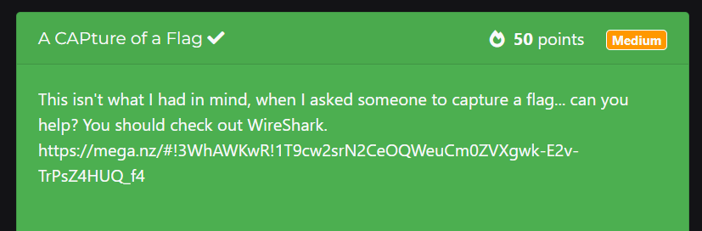
- Was able to download a CAP file which was accessible by wireshark on my Kali machine. I used protocol hierarchy to apply filter for line-based text data and follow the tcp stream of the first packet. The code was in the GET message which when converted from base64 get the flag.
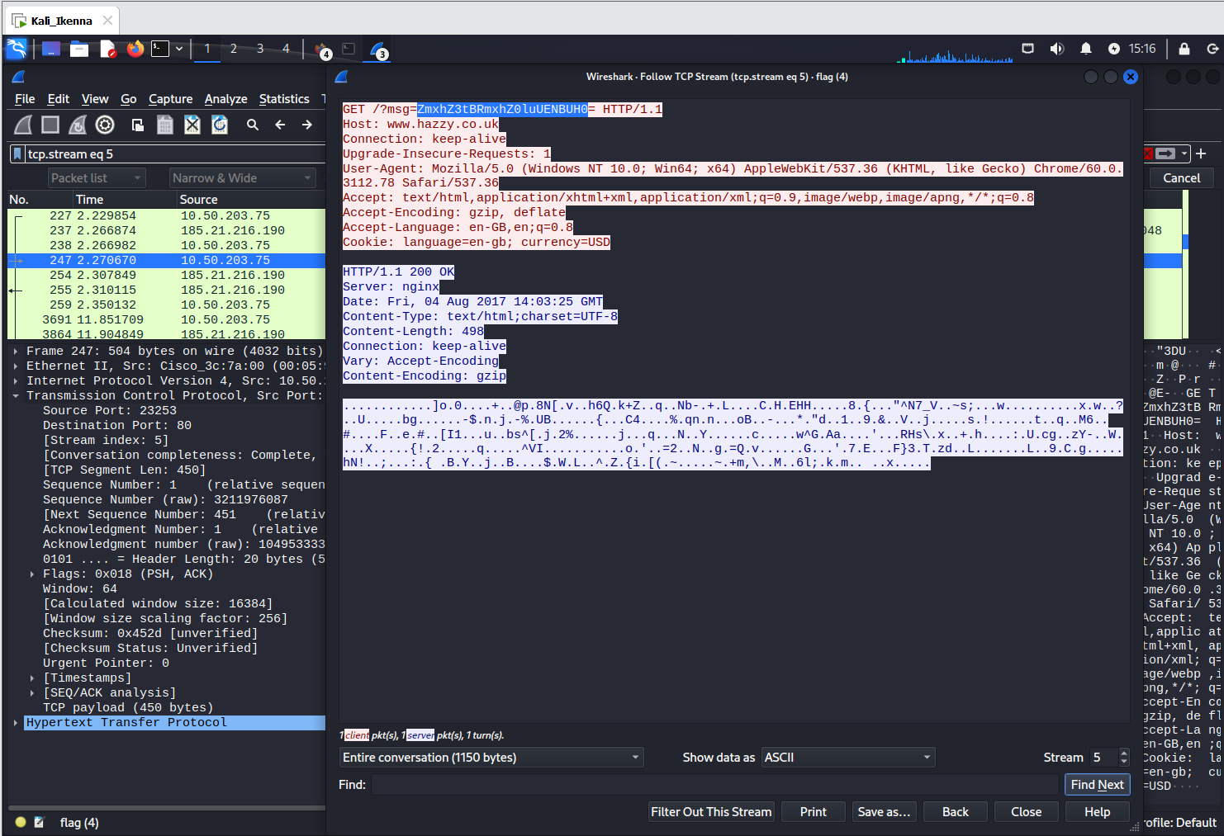
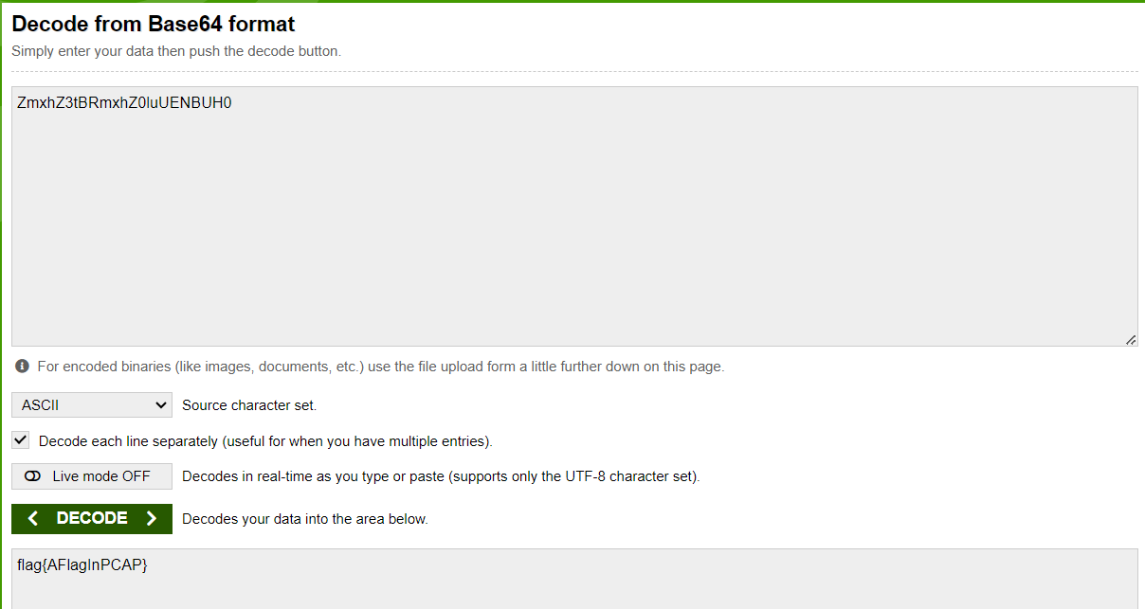

- The adventures of Boris Ivanov. Part 1.
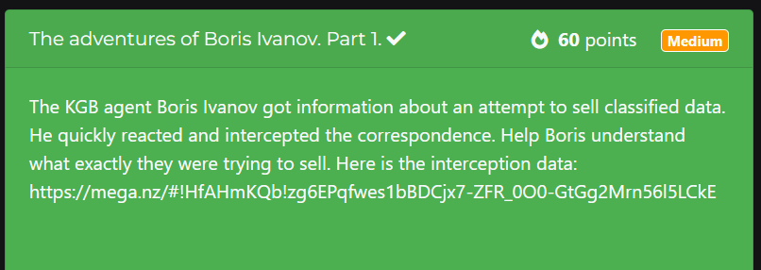
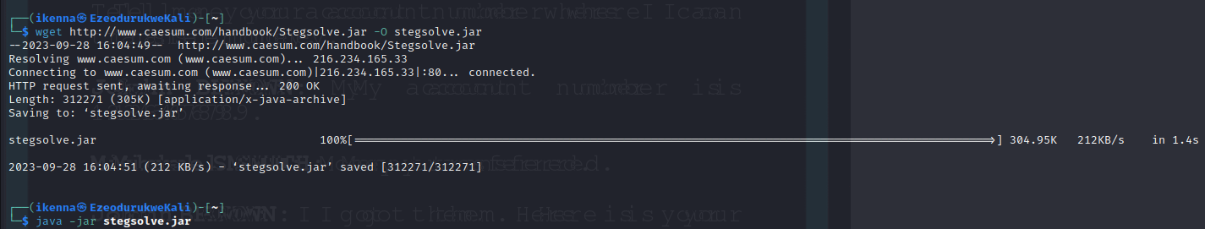
- Install and open stegsolve using the following command. Open picture from download folder,
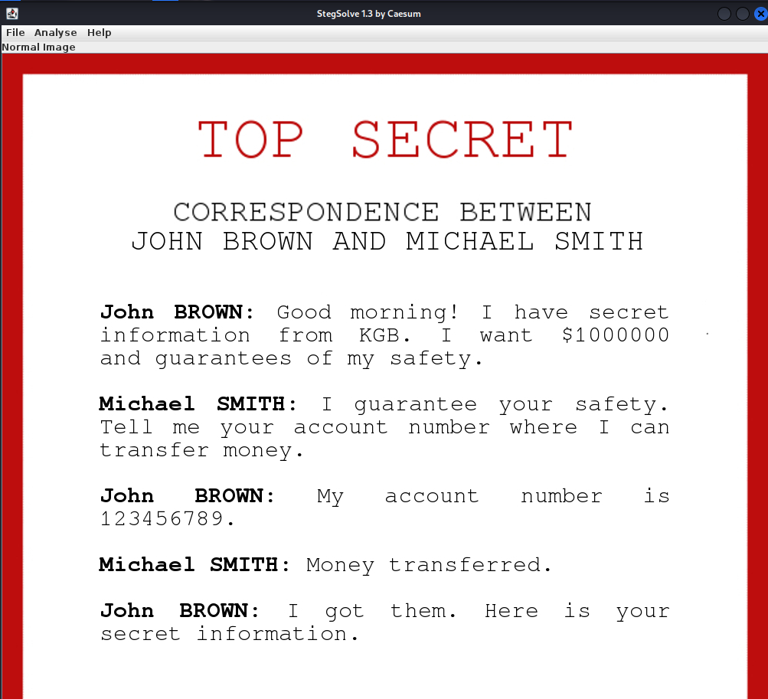
- Under analyse use the stereogram solver and offset until the flag is legible in the bottom part of the picture to get flag Flag{d0nt_m3ss_w1th_th3_KGB} at offset 102
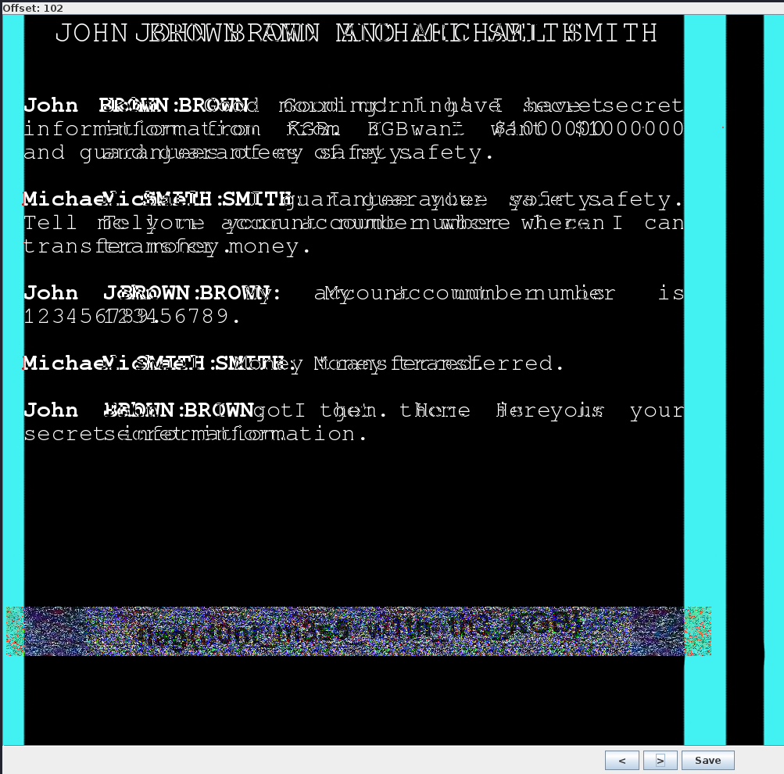

- Basic SQL injection
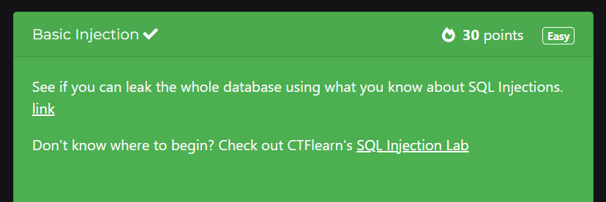
- Sql input “or 1 or” broke the database to show flag.
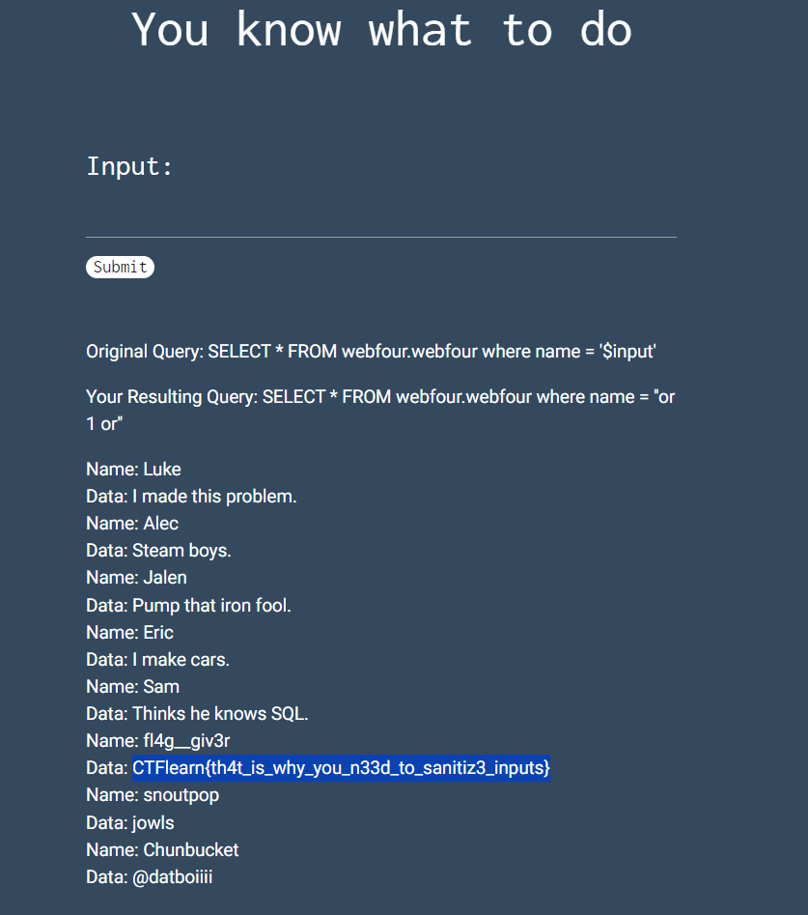

- Forensics 101
